BYOD CA2 SCM

Part A: Setup and Initial Commits
Repository Setup:
Create a new directory for the lab.
Initialize a new Git repository.
Create an initial file (e.g., app.py or index.html) with some content.
Stage and commit your changes.
Build the Commit History:
Make at least two additional changes to your file(s) and commit each change.
Verify that your commit history contains multiple commits.
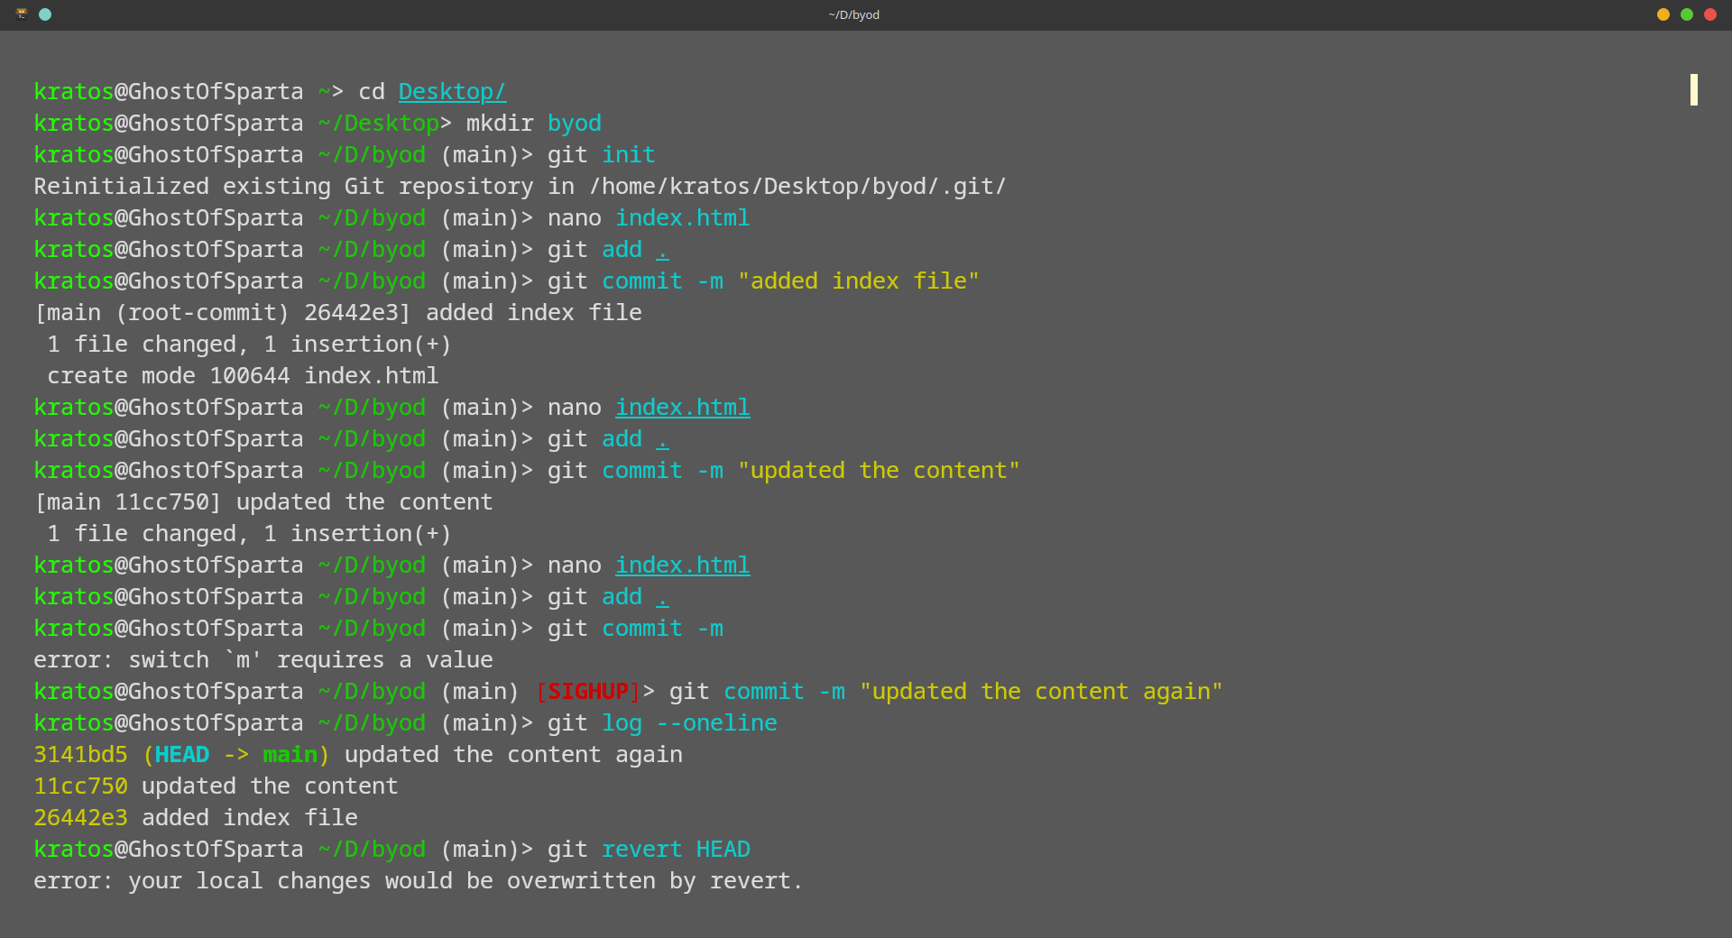

Part B: Rollbacks in Git
Explore Commit History:
Use a Git command to view your commit history and identify commit hashes.
Reverting Changes:
Use a Git command to revert the latest commit by creating a new inverse commit.
Verify the changes in your file to see the effect of the revert.
Resetting the Repository:
Practice using both soft and hard resets to move the repository state backward.
Observe and document the differences in how each reset type affects the working directory and staging area.
￼Reflection:
Briefly describe the role of HEAD in Git and how it changes during resets.

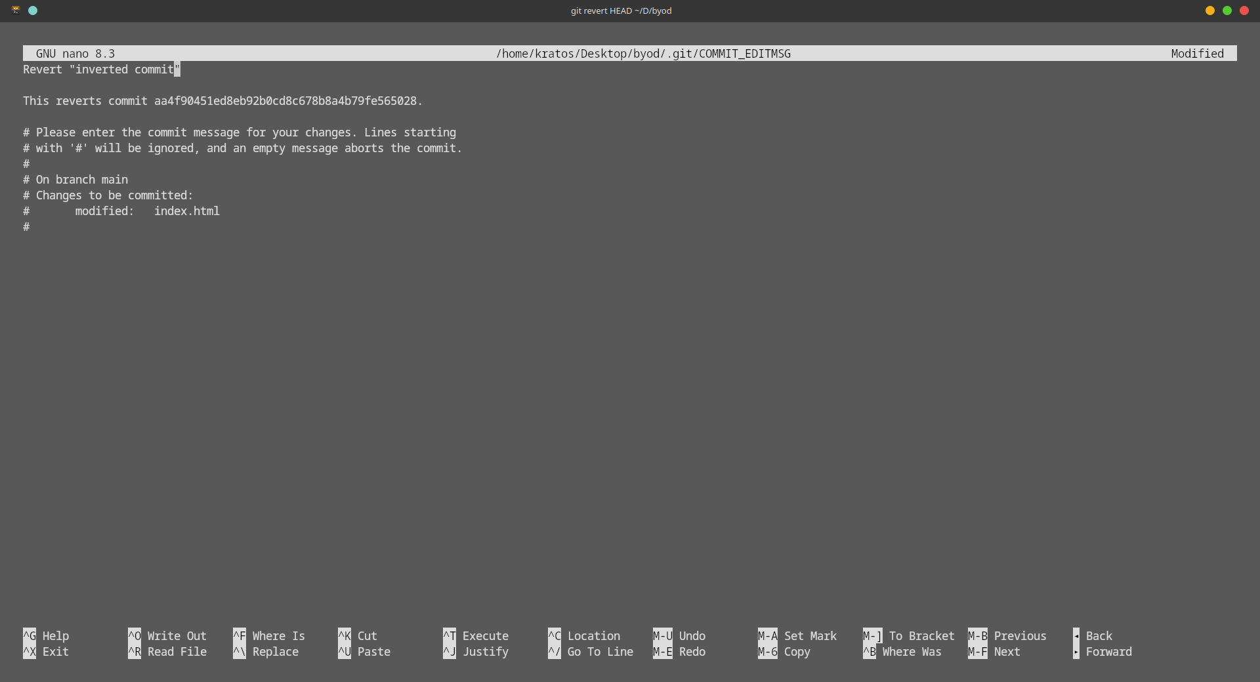

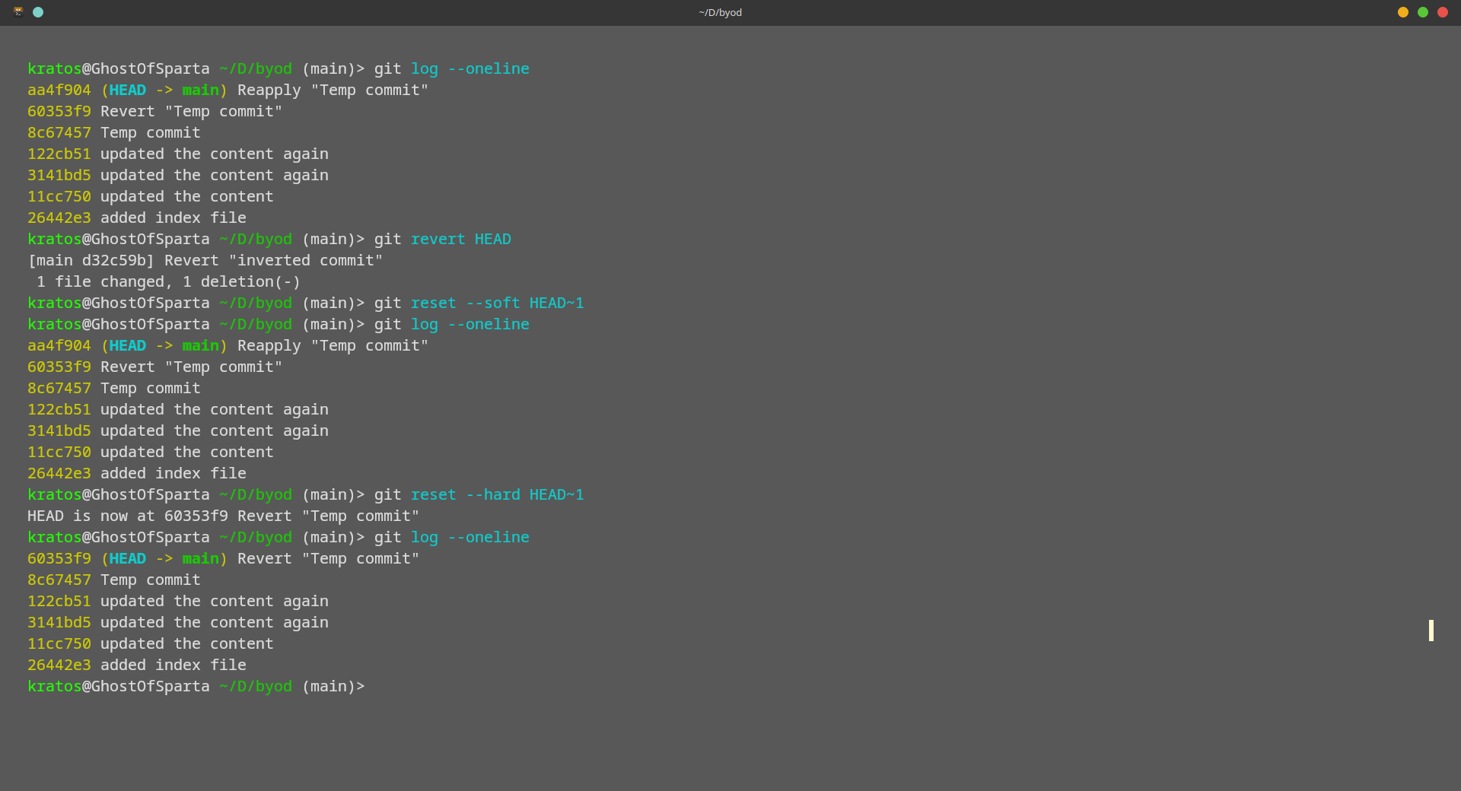

Part C: Merge Conflict Resolution
Branch Creation and Divergence:
Create a new branch to simulate parallel development.
Modify the same section of a file differently on this new branch and commit the change.
Switch back to the main branch, make a different modification to the same section, and commit.
Merging and Conflict:
Attempt to merge the new branch into the main branch.
Encounter and identify the merge conflict.
Conflict Resolution:
Manually resolve the merge conflict by editing the conflicting file.
Stage and commit the resolution.
Reflection:
Explain how the merge conflict occurred and outline the steps you took to resolve it.

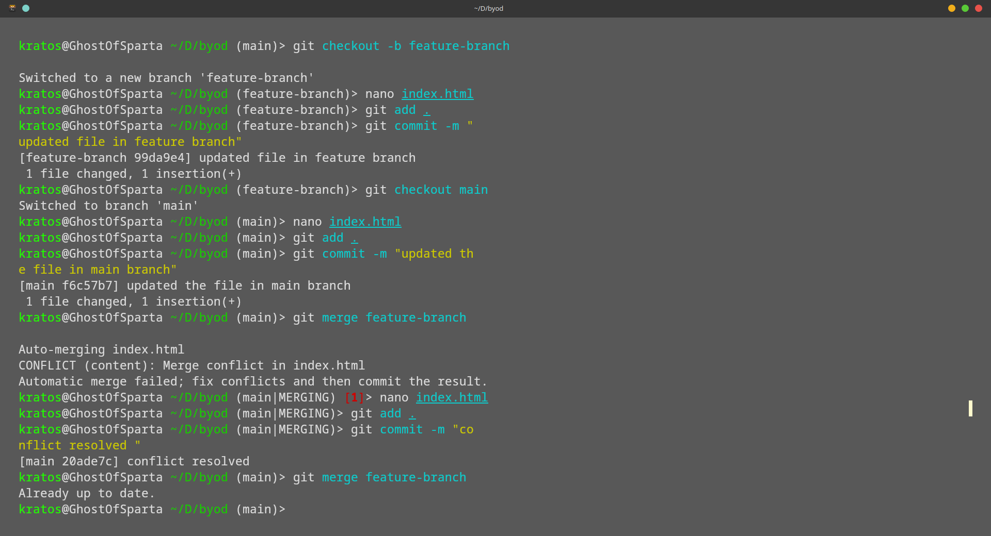

Part D: Rebasing vs. Merging
Branch Experimentation:
Create another branch for experimenting with rebasing.
Make a couple of commits on this branch.
Main Branch Update:
Switch back to the main branch and make an update commit.
Perform a Rebase:
Rebase the experimental branch onto the updated main branch.
Resolve any conflicts that arise during the rebase process.
Comparison:
Reflect on the differences between merging and rebasing in terms of commit history and workflow.

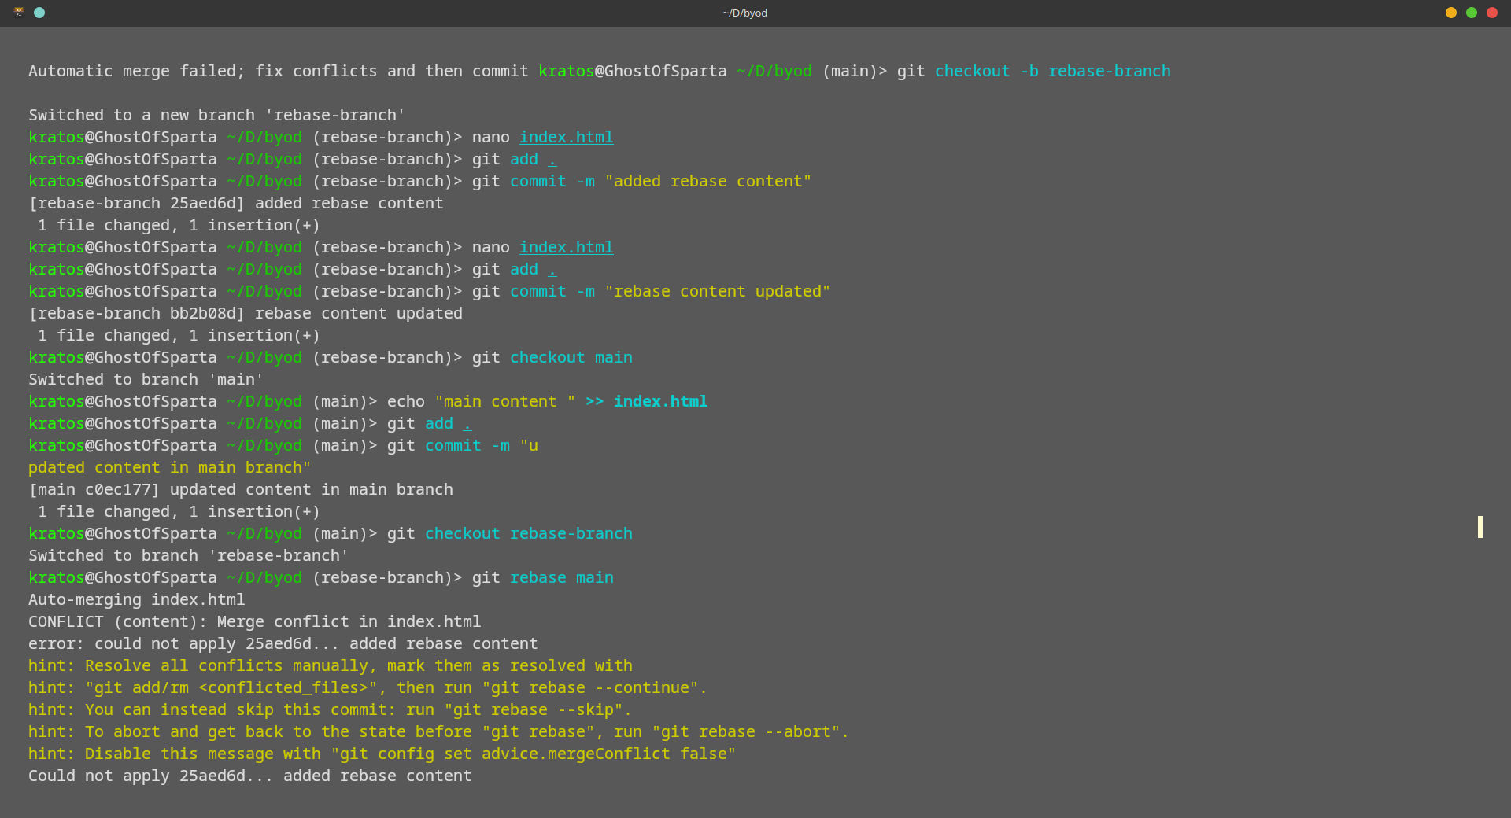
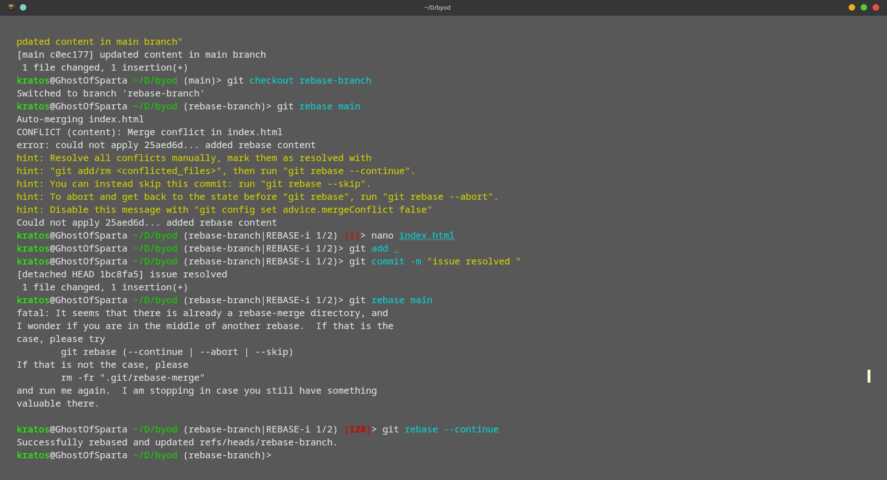

Part E: Reverting a Specific Commit
Commit Identification:
Identify a specific commit from your history that you want to undo.
Reverting:
Use Git to revert that specific commit.
Verify that a new commit has been created which undoes the changes introduced by the original commit.
Reflection:

Summarize how reverting a commit differs from resetting the repository.

